Year 10 – Economics and Business – Revision

Test Topics include:

- Key Concepts of Economics and Business
- What is Economics? The Economic Problem (Scarcity)
- Economic Activity
- Economic Performance – Key indicators:
- Economic Growth (GDP)
- Inflation (CPI)
- Unemployment (Rate)
- Unemployment – Types
- The Business Cycle – Phases
- HDI and Living Standards

- State the six key concepts of economics and business by filling in the blanks!

- S________________________________________________________________
- M________________________________ C______________________________
- S_________________________________ and T__________________________
- I________________________________________________________________
- A_________________________________ and M_________________________
- E_____________________________ P_________________________ and L___________________ S________________________________________
- Describe what the study of economics is.

____________________________________________________________________________________________________________________________________________________________________________________________________________________________________________________________________________________________________________________________________________________________
____________________________________________________________________________________________________________________________________________________________________________________________________________________________________________________________________________________________________________________________________________________________
- Define what economic activity is.

______________________________________________________________________________________________________________________________________________________________________________
______________________________________________________________________________________________________________________________________________________________________________
- In the table below, complete each section about the Key Indicators of Economic Performance.
Key Indicator | Economic Growth | Inflation | Unemployment Rate
Definition
How is it calculated?
Australia’s Target
Australia’s Current Measurement
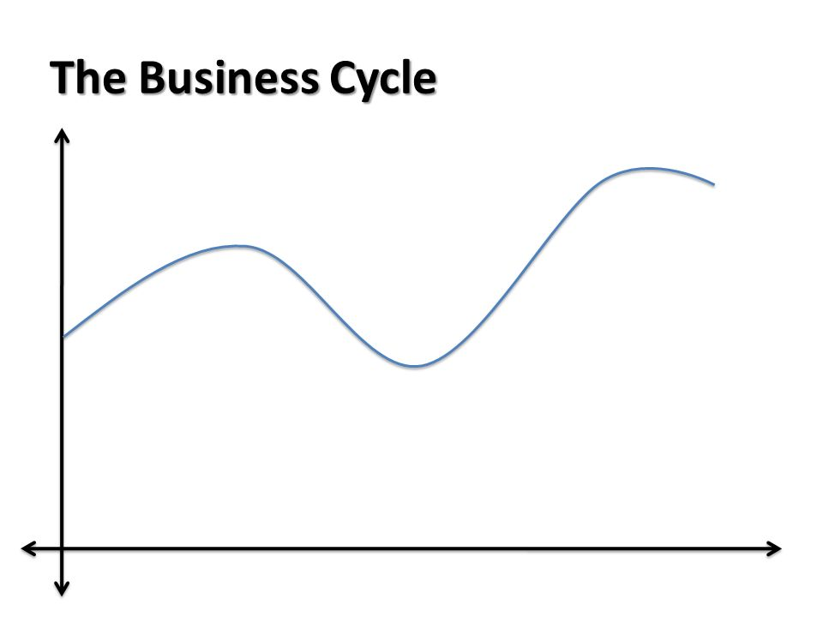
- Label the four phases of the business cycle on the diagram below:

- Causes of Unemployment – 4 main types of unemployment. Read the information below and identify the type of unemployment.

- Occurs when people are unemployed between finishing one job and starting another. E.g. building trades, areas of rural industry

_____________________________________________
- Occurs when the level of spending in the economy falls. When businesses or consumers feel negative (pessimistic) about the economy they tend to save rather than spend. Reduced spending, reducing production, and therefore reduced need for labour.

_____________________________________________
- Occurs as a result of changes in the way goods and services are produced. Production methods change, leading to a mismatch of skills. Job losses often linked to changes in technology. Another cause could be outsourcing.

_____________________________________________
- Results from the termination of jobs at the same time each year due to regular change in seasons. Examples: sheep shearing, working on ski fields.

_____________________________________________

- Ensure you know the meaning of the following key terms, match up the term with the correct definition:
Employed |  | the percentage of people in the labour force that are unemployed.
Unemployed |  | the percentage of people in the working-age population that are in the labour force.
Labour Force |  | includes people who are not in a paid job, but who are actively looking for work.
Unemployment Rate |  | includes people who are in a paid job for one hour or more in a week.
Participation Rate |  | the sum of employed and unemployed people.

- State what HDI stands for: ___________________________________________________________

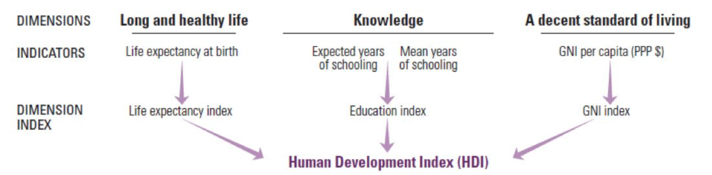
- Using the diagram below, describe what the HDI is and how it is used to give an indication of a country’s development.
______________________________________________________________________________________________________________________________________________________________________________
______________________________________________________________________________________________________________________________________________________________________________
______________________________________________________________________________________________________________________________________________________________________________
______________________________________________________________________________________________________________________________________________________________________________
______________________________________________________________________________________________________________________________________________________________________________
______________________________________________________________________________________________________________________________________________________________________________
______________________________________________________________________________________________________________________________________________________________________________

